
Request for Proposal of
Frame optimization of nacelle of electric engine

2026. 9.
The information in this document is proprietary information of KARI and is disclosed in confidence. The technical data is the property of KARI and shall not be used, disclosed to others or reproduced without the express written consent of KARI, including, but without limitation, it is not to be used in the creation, manufacture, development, or derivation of any repairs, modifications, spare parts, designs, or configuration changes. If consent is given for reproduction in whole or in part, this notice and the notice set forth on each page of this document shall appear in any such reproduction in whole or in part.
Table of Contents
1 General Information 3
1.1 Project Information 3
1.2 Schedule and process 3
1.3 Conditions for modification and cancellation of SOW 4
1.4 Preparation of the proposal 4
1.5 Notes for the preparation of Proposal 5
1.6 Authority of KARI 5
1.7 Maintenance of Secrecy 5
2 Introduction 6
2.1 Conceptual design of a hybrid propulsion system 6
2.2 Electric Engine 6
3 Scope of work 7
3.1 General Description 7
3.2 Topology optimization of lightweight electric-engine nacelle 7
3.3 Kick-Off and Final Meeting 8
4 Other requirements 9
4.1 Meeting room for kick-off and final meetings 9
5 Proposal Requirement 9
5.1 Contents of Proposal requirements 9
5.2 Price proposal 9
6 Terms and Conditions 9
6.1 General terms and conditions 9
6.2 Intellectual property 10

Technical Evaluation Sheets

General Information

Project Information
The Hybrid Electric Propulsion (HEP) system development project, launched in 2026, is a government-funded R&D initiative led by the Korea Aerospace Research Institute (KARI) to develop distributive propulsion system technology for super electric Short Take-Off and Landing (eSTOL) aircraft. The HEP system uses an electric powertrain system to create a high performance and high efficiency propulsion unit. These units consist of a turboshaft, a generator, a rectifier, battery packs, electric motors, inverters, and heat exchangers, see Fig. 1. The integration of these systems within the aircraft requires careful consideration of system-level weight, installation space, structural interfaces, thermal management, and operational requirements.
One of key elements of the HEP system is the nacelle, which serves as the installation platform for the electric engine unit and its associated supporting systems. Unlike a conventional nacelle that primarily provides an aerodynamic enclosure and structural support for the propulsion system; an electric-engine nacelle must accommodate propulsion, power-electronic, thermal-management, and associated interface requirements within a compact installation envelope. Major nacelle-resident components, including the electric motor, inverter, propeller pitch-control hardware, heat exchanger, and cooling pump, need to be arranged such that individual component and combined system requirements are satisfied
This project will perform a preliminary structural frame design of the nacelle using the integrated Multi-Material Topology Optimization and DfAM (Design for Additive Manufacturing) for the light-weight design.

Schedule and process

Schedule and location
Table 1 Schedule
Time | Event
Within one week after contract | KARI provide document for nacelle design for an electric engine
October, 2026 | Kick off meeting
November, 2026 | Interim presentation
One week before final meeting | Submission of final report
Early December, 2026 | Final presentation
18st Dec., 2026 | Contract expiration

Table 2 Payment Schedule
Event | Payment (%)
After kick-off meeting | 50%
After the final report | 50%

Kick off meeting shall be performed at the contractor site but it can be changed (exact date will be determined later)

Final meeting shall be held at the KARI. (exact date and location will be fixed later)

Selection process and schedule

Selection process

Inquiries related with a proposal preparation may be asked or sent by mail to the following persons.
Jae Sung Huh, Ph.D.

Aeropropulsion Research Division
Korea Aerospace Research Institute
169-84 Gwahak-ro, Yuseong-Gu, Daejeon, Korea

jshuh@kari.re.kr
Tel) 82-42-860-2831 / Fax) 82-42-860-2626

Conditions for modification and cancellation of SOW

KARI reserves the right to change or modify the SOW if there is any change in the technical and business requirements of the SOW even after SOW issuance. Upon the incurred changes or modification of the SOW as above, the contractor shall submit the modified proposal in accordance with the specific instructions provided by KARI.

KARI reserves the right to withdraw this SOW at any time with a written notice to the contractor, in case of the proposal provided by the contactor does not meet the requirements of the SOW.

Preparation of the proposal

Proposal shall be prepared in English.

The basic unit shall be SI unit. British unit of power and weight could be used as a complementary unit. SI unit comes first and British unit shall be put in parentheses.

In order to substantiate a proposal, all relevant data shall be submitted as attachments. The proposal which is improvable or based on vague presumptions shall be excluded.

All electronic files including documentary evidences shall be prepared with MS-WORD and submitted by e-mail the address stated in Article 1.2.2.2.

Time and date in the SOW are specified by the Korean Standard Time (GMT+09:00) and Date.

The proposal and relevant documents provided by contractor will not be returned.

Notes for the preparation of Proposal

This proposal constitutes a firm and irrevocable offer. All prices shall remain valid until the final contract.

The contractor shall be responsible for all costs and expenses in preparation of its proposal and clarification with KARI.

Authority of KARI

KARI reserves the right to reject proposals that are unrealistic or unreliable. KARI will not disclose the result of proposal evaluation.

Maintenance of Secrecy

The contractor shall not disclose any part of this SOW without prior permission of KARI.

The contract may not, in any manner, advertise or publish any matter in relation to the contractor’s proposal.

Introduction

Conceptual design of a hybrid propulsion system
A schematic design of a series hybrid propulsion system is shown in Fig. 1. In general, the system features several propellers, and each propeller connects to an electric motor and an inverter which are installed in a nacelle as shown in Fig. 2.

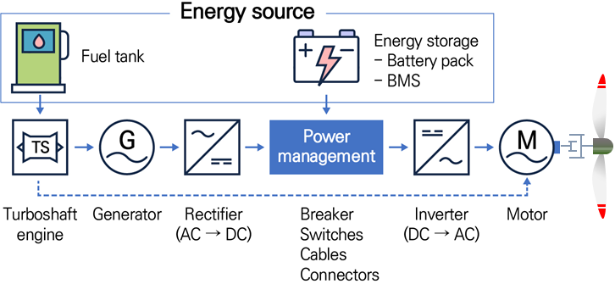
Figure 1. Schematic of HEP system

For the proposed eSTOL application, the electric engine and the related components such as heat exchanger and cooling pump must be contained within a compact nacelle. The nacelle must not only provide adequate space for all components (in a small volume) but also account for their structural and thermal mounting requirements.

Electric Engine
The electric propulsion unit and its supporting systems are integrated within an engine nacelle, as illustrated in Fig. 2. In addition to providing an aerodynamic enclosure, the nacelle accommodates major propulsion, electrical, and thermal-management components, including the electric motor, inverter, propeller pitch-control hardware, heat exchanger, and cooling pump. These components must be integrated within a compact and lightweight envelope while maintaining adequate installation space, accessibility, connections, and structural interfaces.

a) 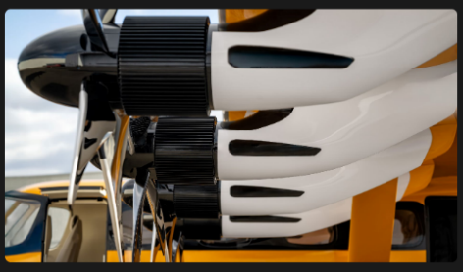
b)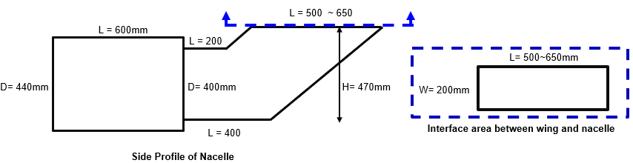
Figure 2. (a) Example of electric engine nacelles (Electra Aero EL9).
(b) The design space available for the eSTOL HEP nacelle.

Scope of work

General Description
The goal of this project is to establish a structural frame design for an electric-engine nacelle based on KARI’s requirements using effective MM-MJ-TO and DfAM in-house codes. The work shall develop initial structural supports within the available nacelle envelope. The initial frame design will consider geometric compatibility, installation and accessibility requirements, mass distribution, thermal-management requirements, and space for electrical and coolant connections. The MM-MJ-TO design will provide a basis for further structural and aerodynamic development later in the project.

Topology optimization of lightweight electric-engine nacelle

KARI shall provide the available design space for a nacelle and relevant information on the major internal components, including their dimensions, mass, thermal characteristics, installation requirements, structural interfaces, and other design information necessary for the proposed work.

Based on the information provided by KARI, the contractor shall propose initial feasible locations and orientations of the major internal components within the available nacelle envelope. The candidate arrangements shall also be used to distinguish the regions occupied or restricted by the installed components from the remaining space available for subsequent structural development. An example illustrating the geometric definition of occupied and available regions within a structural envelope is shown in Fig. 3.
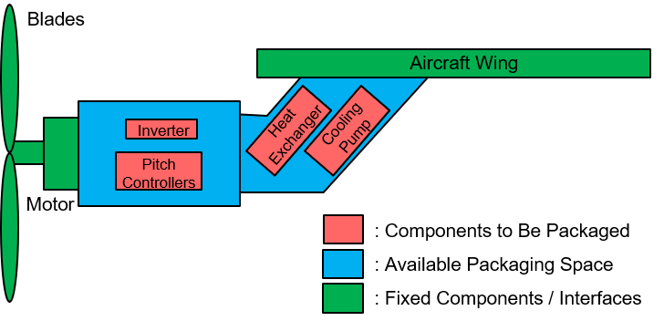
Fig. 3. Schematic of the preliminary nacelle configuration
and component classification

The contractor shall use their own in-house MM-MJ-TO code with DfAM code as needed with the relevant structural interfaces (as identified by the available propulsion-system information provided by KARI) to generate initial structural frame designs. Representative loading information, such as the forces and moments associated with the propeller system and maneuver loading illustrated in Fig. 4, will be utilized to shape the structure topology.
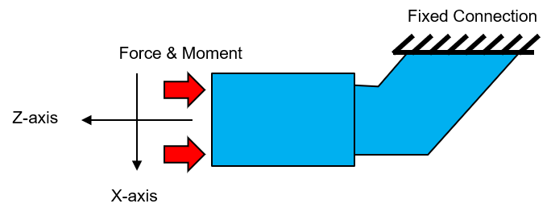 | 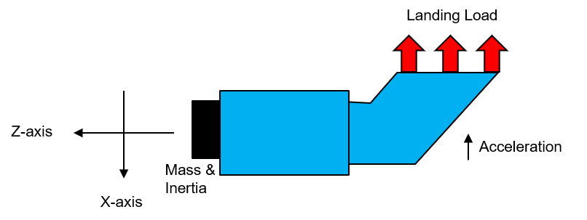
Propeller Loading | Landing Inertia Relief Load Case
Fig. 4. Representative propulsion and landing induced loading conditions

The contractor shall document the preliminary structural design of the frame with associated geometric and interface information. The resulting design shall provide a basis for future structural design refinements and further aerodynamic nacelle development.

Kick-Off and Final Meeting

The contractor shall prepare for and participate in the kick-off and final meetings.

Presentation and supporting materials used during the kick-off and final meetings shall be provided to KARI in electronic file format for project documentation.

If sensitive or restricted information is included, it shall be removed before the materials are provided to KARI.

Other requirements

Meeting room for kick-off and final meetings

A meeting room shall be prepared by contractor for kick-off meeting at contractor’s location

The meeting room shall be equipped with free WIFI.

Proposal Requirement

Contents of Proposal requirements

Proposal summary

Consultants

Consulting team summary

Consultants experiences

Proposal

Scope of work for key topics

A monthly base plan

Price proposal

Estimated Budget: KRW 30,000,000

Price shall be proposed in Korean WON (Y2026).

Contractor shall include all cost items to cover the all activities in their proposals and itemize requested items.

The proposed price shall reflect possible fluctuations in labor costs, material prices and others in the proposed price. Therefore, the contractor shall not demand to reflect the fluctuation in cost due to cost items not stated in the contractor's proposal in the future.
※ The price proposal shall be submitted as one (1) original proposal, sealed separately. The document submitted without the price proposal shall not contain any price information.

Terms and Conditions

General terms and conditions

Shall follow KARI’s terms and conditions

Intellectual property

All results produced shall be jointly owned by KARI and the contractor.

Technical Evaluation Sheets

Evaluation Item | Evaluation Criteria | Weight (%) | Score
Understanding of SOW | Understanding of the objectives of the electric engine nacelle frame optimization and the specific characteristics of the Hybrid Electric Propulsion (HEP) system. | 10
Technical Approach & Methodology | Appropriateness and specificity of the proposed lightweight design methodology utilizing MM-MJ-TO and DfAM. | 30
Design Integration & Analysis Plan | Adequacy of the plan for optimizing the layout of internal components (motor, inverter, heat exchanger, etc.) and incorporating structural and thermal requirements. | 20
Project Schedule & Management | Realism of the proposed schedule and the adequacy of the process management plan leading up to the final report submission. | 10
Relevant Project Experience | Proven track record in aircraft nacelle/airframe structural design or high-level topology optimization projects. | 20
Qualifications of Personnel | Professionalism, academic background, and relevant expertise of the key engineers and researchers assigned to the project. | 10
Total |  | 100

