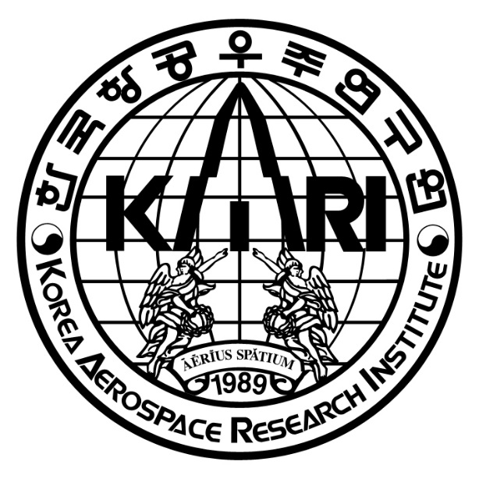
Request for Proposal of
Advisory review of Master Plan (D) of gas turbine engine structural integrity

2026. 7.

The information in this document is proprietary information of KARI and is disclosed in confidence. The technical data is the property of KARI and shall not be used, disclosed to others or reproduced without the express written consent of KARI, including, but without limitation, it is not to be used in the creation, manufacture, development, or derivation of any repairs, modifications, spare parts, designs, or configuration changes. If consent is given for reproduction in whole or in part, this notice and the notice set forth on each page of this document shall appear in any such reproduction in whole or in part.
Table of Contents
1 General Information 3
1.1 Project Information 3
1.2 Schedule and process 3
1.3 Conditions for modification and cancellation of SOW 4
1.4 Preparation of the proposal 5
1.5 Notes for the preparation of Proposal 5
1.6 Authority of KARI 5
1.7 Maintenance of Secrecy 5
2 Introduction 6
2.1 Structural integrity of gas turbine engines 6
2.2 Master Plan for engine structural integrity 6
3 Scope of work 7
3.1 General description 7
3.2 Advisory review of the structural integrity Master Plan 7
3.3 Kick-off and Final meeting 8
4 Other requirements 8
4.1 Meeting room for kick-off and final meeting 8
5 Proposal Requirement 8
5.1 Contents of Proposal requirements 8
5.2 Price proposal 9
6 Terms and Conditions 9
6.1 General terms and conditions 9
6.2 Intellectual property 9

General Information

Project Information
Gas turbine engine structural integrity project, initiated in 2022, is a research and development program led by the Korea Aerospace Research Institute (KARI) and supported by the Government of Republic Korea to establish core technologies for gas turbine engine structural integrity. Aircraft gas turbine engines operate under extremely demanding conditions, including high temperature, high rotational speeds, and complex loading environments. Ensuring the structural integrity of engine components under such conditions is a critical factor for engine safety and certification. Therefore, a systematic structural integrity framework that includes structural analysis, life assessment, damage tolerance evaluation, and reliability-based assessment method is required.
This project mainly addresses the establishment of a structural integrity framework and analytical methodologies for gas turbine engines, and aims to develop a Master Plan for gas turbine engine structural integrity to support these activities.

Schedule and process

Schedule and location
Table 1 Schedule
Time | Event
July, 2026 | RFP release
August, 2026 | Contract
August, 2026 | Kick off meeting
End of every month | Q & A and Review meeting
November or December, 2026 | Finial review meeting
December, 2026 | Contract expiration

Table 2 Payment Schedule
Event | Payment (%)
After kick-off meeting | 10%
After the interim report | 20%
The delivery of the review report | 50%
After the finial report | 20%

Kick off meeting shall be held via video conference., but it can be changed (exact date will be determined later). KARI will release the draft of Master Plan (D)

Q & A and Review meeting shall be held via video conference.

Final review meeting(face-to-face) shall be held at contractor’s location or Korea. (exact date and location will be fixed later)

Selection process and schedule

Selection process

Inquiries related with a proposal preparation may be asked or sent by mail to the following persons.
Jae Sung Huh, Ph.D.

Aeropropulsion Research Division
Korea Aerospace Research Institute
169-84 Gwahak-ro, Yuseong-Gu, Daejeon, Korea

jshuh@kari.re.kr
Tel) 82-42-860-2831 / Fax) 82-42-860-2626

Conditions for modification and cancellation of SOW

KARI reserves the right to change or modify the SOW if there is any change in the technical and business requirements of the SOW even after SOW issuance. Upon the incurred changes or modification of the SOW as above, the contractor shall submit the modified proposal in accordance with the specific instructions provided by KARI.

KARI reserves the right to withdraw this SOW at any time with a written notice to the contractor, in case of the proposal provided by the contactor does not meet the requirements of the SOW.

Preparation of the proposal

Proposal shall be prepared in English.

The basic unit shall be SI unit. British unit of power and weight could be used as a complementary unit. SI unit comes first and British unit shall be put in parentheses.

In order to substantiate a proposal, all relevant data shall be submitted as attachments. The proposal which is improvable or based on vague presumptions shall be excluded.

All electronic files including documentary evidences shall be prepared with MS-WORD and submitted by e-mail the address stated in Article 1.2.2.2.

Time and date in the SOW are specified by the Korean Standard Time (GMT+09:00) and Date.

The proposal and relevant documents provided by contractor will not be returned.

Notes for the preparation of Proposal

This proposal constitutes a firm and irrevocable offer. All prices shall remain valid until the final contract.

Authority of KARI

KARI reserves the right to reject proposals that are unrealistic or unreliable. KARI will not disclose the result of proposal evaluation.

Maintenance of Secrecy

The contractor shall not disclose any part of this SOW without prior permission of KARI.

The contract may not, in any manner, advertise or publish any matter in relation to the contractor’s proposal.

Introduction

Structural integrity of gas turbine engines
Aircraft gas turbine engines are complex mechanical systems operating under severe environments characterized by high temperatures, high rotational speeds, and combined thermal and mechanical loading. Under these conditions, engine components are exposed to various damage mechanisms such as fatigue, creep, and vibration, which may affect their long-term structural reliability.
The structural integrity of engine components is therefore a key consideration throughout the engine development process. Components such as compressors, combustors, turbines must be designed and evaluated to withstand demanding operating conditions while maintaining the required safety margins.
In addition, aircraft propulsion systems are subject to strict structure integrity requirements. International aviation authorities, including FAA and EASA, establish certification standards to ensure the safety and reliability of aircraft engines. These standards require comprehensive evaluation and verification of the structural integrity of critical engine components.

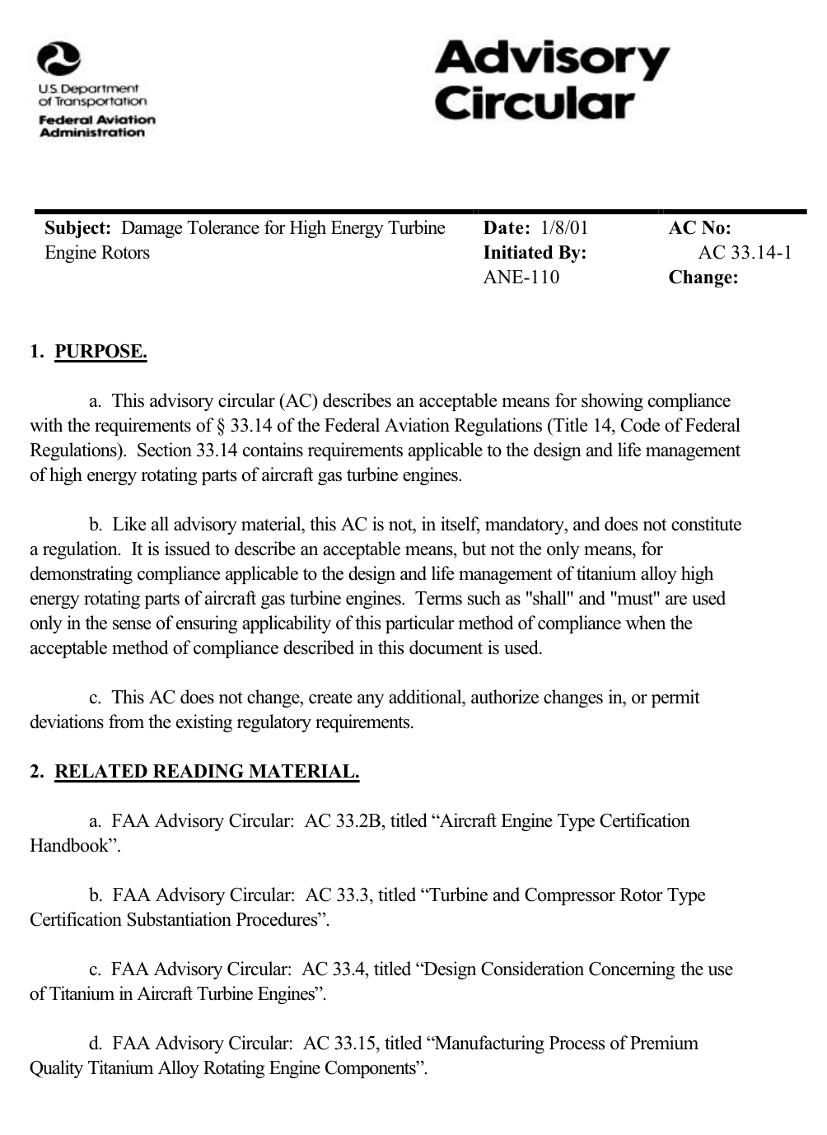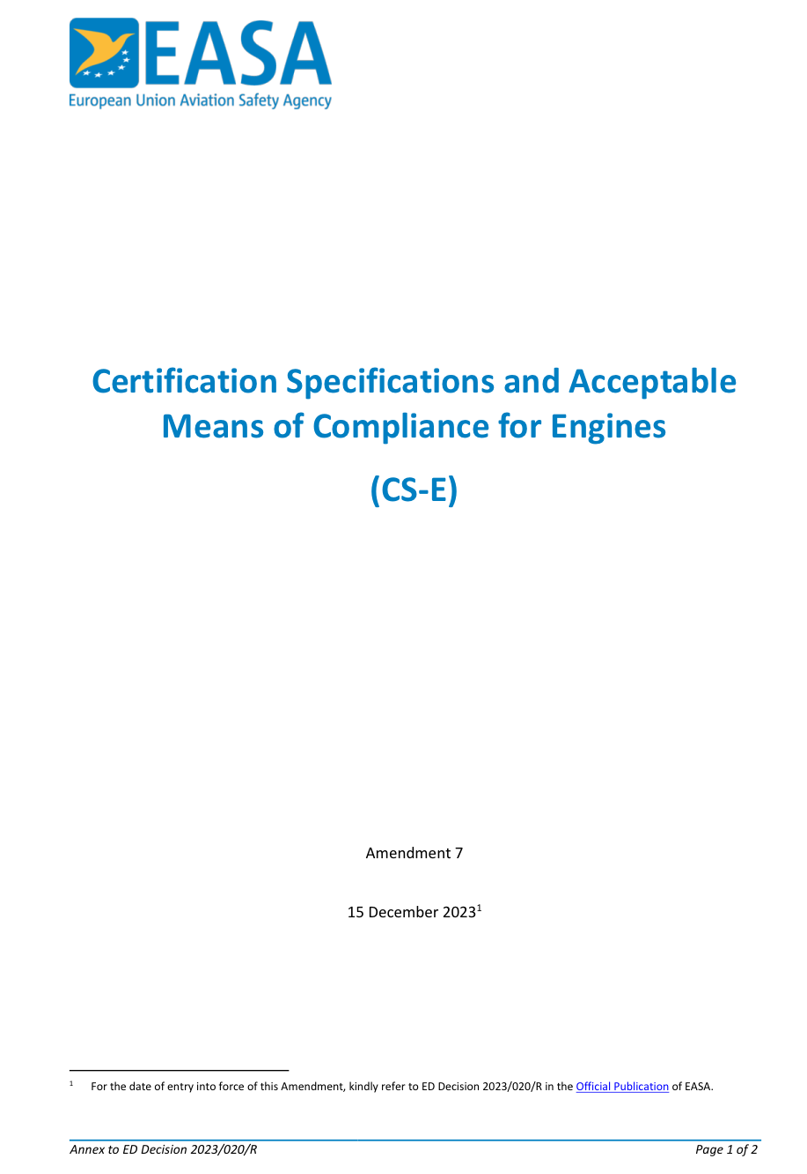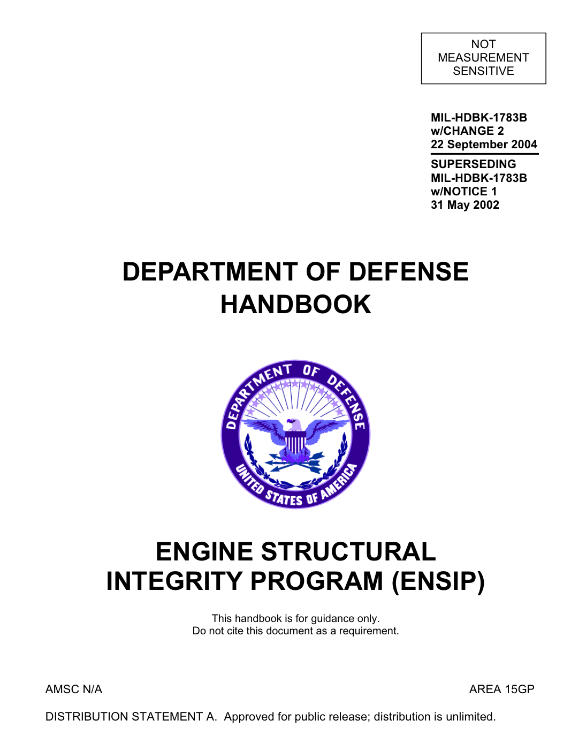
Figure 1. Structural integrity programs (FAA, EASA, MIL)

Master Plan for engine structural integrity
To effectively address structural integrity requirements during engine development, a systematic and integrated approach is necessary. This approach should define the analytical methodologies, evaluation procedures, and technical strategies required to assess structural integrity throughout the engine lifecycle.
For this purpose, a structural integrity Master Plan is required to provide a structured framework for managing structural integrity considerations in engine development programs. The Master Plan is intended to outline the methodologies and processes necessary to support structural integrity evaluation and to guide future gas turbine engine development activities.

Scope of work

General description
The goal of this project is to conduct a technical advisory review of the gas turbine engine structural integrity Master Plan developed by KARI and to provide recommendations for improving its technical completeness and applicability. The selected contractor shall review the draft of Master Plan(D) and provide expert advisory input based on international best practice in gas turbine engine structural integrity and airworthiness certification. The advisory activities are expected to support the establishment of a systematic framework for structural integrity management and to enhance the technical foundation for future gas turbine engine development programs.

Advisory review of the structural integrity Master Plan
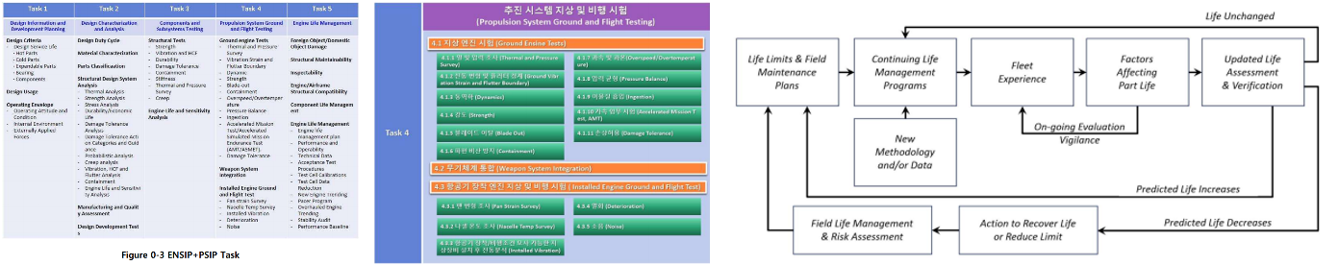

Fig. 2. Sample of Master Plan(D) draft
The contractor shall review the draft of gas turbine engine structural integrity Master Plan provided by KARI and provide technical advisory services on the following aspects:

Seminar on development process and specifications about engine structural integrity
- Development process of turbine engine structural integrity based on specifications and the role of Master Plan
- Contents and details which shall be included in Master Plan
- Similarities of specifications of FAA, EASA, and MIL on engine structural integrity
- Introduction of planning documents to be submitted such as Master Plan, Engineering Plan, Manufacturing Plan, and etc.

Advisory reviews about a draft of Master Plan for engine structural integrity
- Advisory review and recommendations of the Master Plan(D) provided by KARI that include appropriateness of Plan(D) structure, chapter and section divisions, degree of details, and etc.
- Relationship between tasks of the Master Plan(D) and system engineering reviews milestones
- Lists of verification documents to be submitted to Aviation Safety Agency
- List of required ground test facilities for engine structural integrity
- Development activities on engine structural integrity not included in the specifications

Questions and answers about detailed technical items.
- Technical questions on each requirement in CS-E, FAA AC, and MIL specifications
- Engine-airframe structural interactions or compatibility
- Various questions related on engine structural integrity during review process

Advisory review report, which includes seminar presentation material, answers on the questions, shall be submitted one week before the final meeting in MS WORD or MS Power Point format.

Kick-off and final meeting

The contractor shall prepare for kick off and final meeting as stated in 1.2.1

To leave evidence for kick-off and final meetings, lecture materials presented during kick-off meeting and final meeting shall be provided to KARI in electronic file format

If sensitive information is included, it should be removed and provided to KARI.

Other requirements

Meeting room for kick-off and final meetings

A meeting room shall be prepared by KARI if the meeting is held in Korea. If the meeting is held at the contractor’s location, contractor shall prepare the meeting room.

The meeting room shall be equipped with free WIFI.

Proposal Requirement

Contents of Proposal requirements

Proposal summary

Consultants

Consulting team summary

Consultant’s experiences

Proposal

Scope of work for key topics

A monthly base plan

Price proposal

Estimated Budget: KRW 88,000,000

Price shall be proposed in Korean WON (Y2026).
※ The price proposal shall be submitted as one (1) original proposal, sealed separately. The document submitted without the price proposal shall not contain any price information.

Contractor shall include all cost items to cover the all activities in their proposals and itemize requested items.

The proposed price shall reflect possible fluctuations in labor costs, material prices and others in the proposed price. Therefore, the contractor shall not demand to reflect the fluctuation in cost due to cost items not stated in the contractor's proposal in the future.

Terms and Conditions

General terms and conditions

Shall follow KARI’s terms and conditions

Intellectual property

All results produced belongs to both KARI and contractor.

Technical Evaluation Sheets

ENSIP Master Plan Advisory Review Service
Evaluation Item | Evaluation Criteria | Weight (%) | Score
Understanding of Scope of Work | Understanding of the objective and scope defined in the RFP and SoW | 10
Regulatory Framework Coverage | Adequacy of proposed coverage for CS-E, FAA, MIL standards, and guidelines | 10
Review Methodology | Adequacy of preliminary review, final review, gap identification, and compliance assessment approach | 10
Q&A Support Plan | Adequacy of Q&A session organization, technical support process, and responsiveness | 10
Deliverables | Completeness and appropriateness of proposed deliverables, reports, and review outputs | 10
Airworthiness Certification Experience | Relevance of certification experience in turbine engine structural integrity at a major aircraft engine OEMs (e.g., GE Aerospace, Pratt & Whitney, Rolls-Royce, or Safran Aircraft Engines). | 30
Consultant  Experience | Relevance of consulting experience in turbine engine structural integrity and certification activities | 20
Total |  | 100

