
Request for Proposal of
Package optimization and Light weight design for Hybrid Electric Propulsion system
Technical Consulting

2021. 3. 30
The information in this document is proprietary information of KARI and is disclosed in confidence. The technical data is the property of KARI and shall not be used, disclosed to others or reproduced without the express written consent of KARI, including, but without limitation, it is not to be used in the creation, manufacture, development, or derivation of any repairs, modifications, spare parts, designs, or configuration changes. If consent is given for reproduction in whole or in part, this notice and the notice set forth on each page of this document shall appear in any such reproduction in whole or in part.
Table of Contents
1 General Information 3
1.1 Project Information 3
1.2 Schedule and process 3
1.3 Conditions for modification and cancellation of SOW 4
1.4 Preparation of the proposal 4
1.5 Notes for the preparation of Proposal 5
1.6 Authority of KARI 5
1.7 Maintenance of Secrecy 5
2 Introduction 6
2.1 Conceptual design of a hybrid propulsion system 6
2.2 Electric Engine Nacelle 7
2.3 Battery pack housing 7
3 Scope of work 7
3.1 General description 7
3.2 Packaging optimization 7
3.3 Light weight design 8
3.4 Kick-off and Final meeting 8
4 Other requirements 8
4.1 Meeting room 8
5 Proposal Requirement 9
5.1 Contents of Proposal requirements 9
5.2 Price proposal 9
6 Terms and Conditions 9
6.1 General terms and conditions 9
6.2 Intellectual property 9

General Information

Project Information
A Hybrid Electric Propulsion (HEP) system development project launched in 2021 is a basic technology R&D project which is led by Korea Aerospace Research Institute and funded by the ROK government. This project was initiated by the needs of adopting a gas turbine engine based-hybrid electric propulsion system for a long endurance and high payload eVTOL (e-Vertical Take-Off and Landing). All electric VTOL is known as to have limitations of payload and range due to restricted energy density of Li-Ion battery. The goal of this project covers to establish an optimal design of the hybrid electric propulsion system and to do the HEP system performance test at a newly constructed ground test facility. The HEP system has many components such as a turboshaft engine, a generator, a rectifier, several battery packs, motors, inverters, heat exchangers, and etc. It requires the layout deign for effective package and the light weight design using DfAM (Design for Additive Manufacturing). Therefore, this technical project will cover the packaging optimization of an electric engine nacelle and the light weight design of a battery pack housing.

Schedule and process

Schedule and location
Table 1 Schedule
Time* | Event
Within one week after contract | KARI provide document for design of an electric engine nacelle and geometry of battery cell
TBD | Kick off meeting
One week after optimization formulation | Interim presentation
One week before final meeting | Submission of final report
End of Nov., 2021 | Final presentation
15st Dec., 2021 | Contract expiration
*) Earlier is better

Kick off meeting shall be performed at the contractor site but it can be changed due to COVID-9. (exact date will be determined later)

Final meeting shall be held at the KARI. (exact date and location will be fixed later)

Selection process and schedule

Selection process

Inquiries related with a proposal preparation may be asked or sent by mail to the following person.
Jae Sung Huh, Ph.D.

Aeropropulsion Research Division
Korea Aerospace Research Institute
169-84 Gwahak-ro, Yuseong-Gu, Daejeon, Korea

jshuh@kari.re.kr
Tel) 82-42-860-2831 / Fax) 82-42-860-2626

Conditions for modification and cancellation of SOW

KARI reserves the right to change or modify the SOW if there is any change in the technical and business requirements of the SOW even after SOW issuance. Upon the incurred changes or modification of the SOW as above, the contractor shall submit the modified proposal in accordance with the specific instructions provided by KARI.

KARI reserves the right to withdraw this SOW at any time with a written notice to the contractor, in case of the proposal provided by the contactor does not meet the requirements of the SOW.

KARI reserves right to cancel the contract, if the contractor cannot get the approvals for the export license from the concerned governments within one month after the contract.

Preparation of the proposal

Proposal shall be prepared in English.

The basic unit shall be SI unit. British unit of power and weight could be used as a complementary unit. SI unit comes first and British unit shall be put in parentheses.

In order to substantiate a proposal, all relevant data shall be submitted as attachments. The proposal which is improvable or based on vague presumptions shall be excluded.

All electronic files including documentary evidences shall be prepared with MS-WORD and submitted by e-mail the address stated in Article 1.2.2.2.

The contractor shall obtain all required approvals for export license from the contractor’s government.

In case of any changes herein including cancellation of the program, KARI will notify contractor.

Time and date in the SOW are specified by the Korean Standard Time (GMT+09:00) and Date.

The proposal and relevant documents provided by contractor will not be returned.

Notes for the preparation of Proposal

This proposal constitutes a firm and irrevocable offer. All prices shall remain valid until the final contract.

The negotiated price shall not exceed the price initially proposed except when KARI requires additional items during negotiation.

The contractor shall be responsible for all costs and expenses in preparation of its proposal and negotiation with KARI.

Authority of KARI

KARI reserves the right to reject proposals that are unrealistic or unreliable. KARI will not disclose the result of proposal evaluation.

Maintenance of Secrecy

The contractor shall not disclose any part of this SOW without prior permission of KARI.

The contract may not, in any manner, advertise or publish any matter in relation to the contractor’s proposal.

Introduction

Conceptual design of a hybrid propulsion system
A schematic design of a series hybrid propulsion system is shown in Fig. 1, and in general, the system features a couple of cruise propellers (or prop-rotors) and several lift prop-rotors. Each cruise propeller or lift prop-rotor connects to an electric motor and an inverter which are installed in an electric engine nacelle with accessary components for thermal management system and tilting mechanism as shown in Fig. 2.
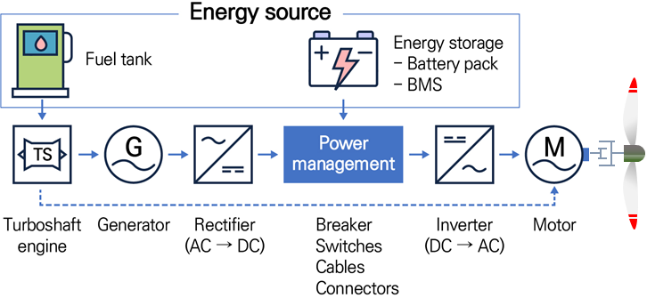
Figure 1. Schematic of HEP system

Electric Engine Nacelle
An electric engine nacelle has a motor, inverters and cooling devices, and the cooling system consists of a heat exchanger, a fluid pump, a fluid tank, a fan, and several valves as shown in Fig. 2. To minimize cruise drag, the nacelle has the size limitation and all components should be laid out efficiently in the limited space.
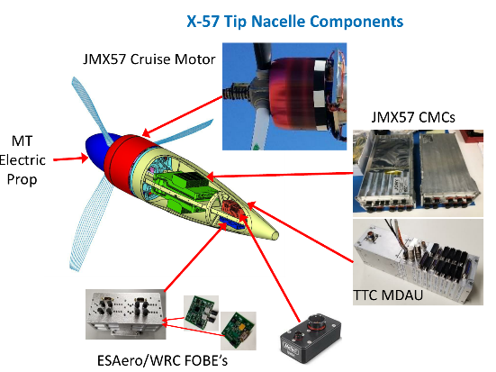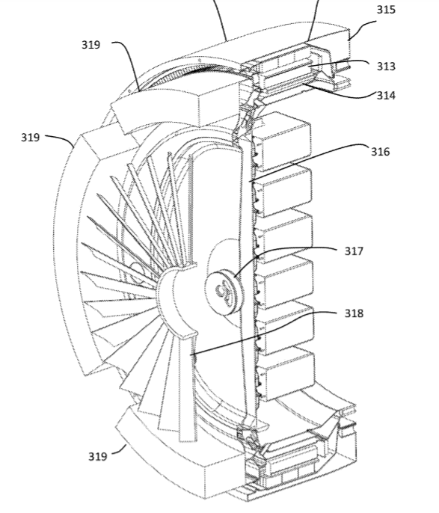
Figure 2. Example of electric engine nacelles (Left: NASA X-57 Nacelle, Right: US 2019/0329859A1)

Battery pack housing
A hybrid propulsion system has two power sources such as turbo-generator and Li-Ion battery which satisfy the high-energy and high-power requirements respectively. The Li-Ion battery has lower energy density and therefore the mass of battery pack should be minimized under some constraints of cooling effectiveness and structural integrity.

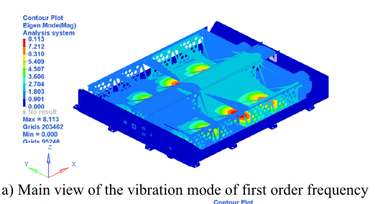
Figure 3. Example of topology optimization of a batter pack housing

Scope of work

General description
The goal of this project is to define the mathematical model and formulation for packaging optimization and light weight design, and to solve the optimization problem with advanced in-house code that the contractor has. Finally, the optimized geometry and the next work scope shall be proposed.

Packaging optimization

KARI will provide the geometry of the electric engine nacelle and the list of all components in it, which could include a motor, inverters, a heat exchanger, a water pump, a water tank, a cooling fan and etc.

The contractor shall generate a simplified model, which can also describe the interface with other components, of all components in the electric engine nacelle.

The contractor shall define the mathematical model/formulation for packaging optimization which can describe the efficient layout of all components in the nacelle envelope and shall discuss it with KARI.

If necessary, the contractor shall customize the in-house code that the contractor has been developing, and then solve the packaging optimization formulation with its own code.

The contractor shall provide the interim optimized result, and shall suggest the next research scope.

The results of packaging optimization and the plan shall be provided within one week before final meeting and prepared in MS WORD or MS Power Point format by KARI.

Lightweight design of battery pack housing

KARI will provide the geometry of a battery cell selected by KARI, and the surface temperatures measured from the discharging test of the battery cell if possible.

The contractor shall generate the partial model of the battery pack housing, which considers the periodic layout of battery cells in the pack

The contractor shall define the mathematical problem for topology optimization of the battery pack housing, and the formulation shall consider structural integrity, vibration characteristics, and heat dissipation capability. However, these performance functions are not limited.

If necessary, the contractor shall customize the in-house code that the contractor has been developing, and then solve the topology optimization problem.

The contractor shall post-process the optimized geometry and shall propose both of the interim design of the battery pack housing and the next process for optimizing the full model of battery pack housing.

The optimization report and the plan shall be submitted within one week before final meeting and prepared in MS WORD or MS Power Point format by KARI.

Advisory review report shall be submitted one week before the final meeting in MS WORD or MS Power Point format.

Kick-off and final meeting

The contractor shall prepare for kick off and final meeting as stated in 1.2.1

To leave an evidence for kick-off and final meetings, lecture materials presented during kick-off meeting and final meeting shall be provided to KARI in electronic file format

If sensitive information is included, it should be removed and provided to KARI.

Other requirements

Meeting room for kick-off and final meetings

A meeting room shall be prepared by contractor for kick-off meeting at contractor’s location

The meeting room shall be equipped with free WIFI.

Proposal Requirement

Contents of Proposal requirements

Proposal summary

Consultants

Consulting team summary

Consultants experiences

Proposal

Scope of work for key topics

A monthly base plan

Price proposal

Price shall be proposed in Korean WON (Y2021).

Contractor shall include all cost items to cover the all activities in their proposals and itemize requested items.

The proposed price shall reflect possible fluctuations in labor costs, material prices and others in the proposed price. Therefore, the contractor shall not demand to reflect the fluctuation in cost due to cost items not stated in the contractor's proposal in the future.

Terms and Conditions

General terms and conditions

Shall follow KARI’s terms and conditions

Intellectual property

All deliverable items(results) produced belongs to KARI.

Taxes

The VAT incurred in KOREA is excluded and will be taken in charge by KARI

As of the time of this proposal, the Applicable Tax (i.e. Corporation taxes (withholding taxes), herein referred to as “Applicable Tax”) is excluded from the Total Price. KARI shall withhold the Applicable Tax and pay on behalf of Contractor to the relevant Korean taxing authority in accordance with applicable Korean law.

Miscellaneouss
- Contract
. The Contract will be effective subject to the KARI’s approval thereof. The draft of Contract will be provided and be the basis of the Contract negotiation with the Successful Bidder.
- Certificate and Government Approvals
. If necessary, Bidder shall receive the government approval and certificates (e.g. export licenses) in relevant countries, necessary for Bidder’s work for the RFP.
- Confidentiality
. There shall be no news release, public announcements, denials or confirmation in connection with the RFP or Contract award without the prior written approval of KARI. All elements of the RFP shall be kept confidential, and shall not be intentionally disclosed by Bidder to any Third Party.
- Withdrawal of Proposal
. Bidder may withdraw its Proposal at any time before the Bid Closing Date and Time. Withdrawal shall be made in writing, and shall be received by KARI before the Bid Closing Date and Time.
- Property of Proposal
. All documents submitted in response to the RFP shall become the property of KARI and will be retained by KARI.
- Expenses
. Expenses incurred by Bidder in connection with the preparation, submission, and any subsequent clarification or negotiation activities are for its own account and will not be reimbursed by KARI
- Governing Law
. The RFP and Contract shall be construed in accordance with and governed by the laws of the Republic of Korea.
- Arbitration
. Any disputes in relation to, and under the RFP and Contract shall be resolved through arbitration in Seoul, Korea under the Rules of the Korean Commercial Arbitration Board.

